|  |  |
| --- | --- |
| Stella Nova Logo | LOGO4 |
| Best Buy Canada Mobile | |
| |  | | --- | | **Kits on the Fly Feature Document** |   **Document Version: 1.0**  **Design Date: July 16, 2013** | |
| **Prepared By: Amy Lackas** | |
|  | |

**Table of Contents**

*1.* *Feature Overview* 3

1.1 Feature Description 3

1.2 Assumptions 3

1.3 Parameters and System Settings 3

1.4 Interfaces 3

*2.* *USE CASE: Kits on the Fly* 4

2.1 Feature Flow 4

2.2 Precondition 5

2.3 Main Flow 5

2.4 Alternate Flows 5

2.5 Post Condition 6

2.6 Special Requirements 6

*3.* *Supplemental Specifications* 7

3.1 Deal Service Feature 7

3.2 Electronic Journal 7

3.3 Item Modify Feature 7

3.4 Line Item Delete Feature 8

3.5 Manager Override 8

3.6 Modify Transaction 8

3.7 POSLog 8

3.8 Printed Receipts 8

3.9 Suspend 8

*4.* *Screen Layouts* 9

4.1 Kit on the Fly Menu 9

4.2 Item Entry – Create Kit 11

4.3 Item Entry – Edit Kit 12

4.4 Enter Kit Price – Create Kit 13

4.5 Enter Kit Price – Edit Kit 14

4.6 Item Entry – With Kit Items 15

*5.* *Business Sign Off* 16

*6.* *Revision History* 16

*7.* *Appendix A: Glossary* 16

# *Feature Overview*

## Feature Description

Kits on the Fly are used to manually create a temporary package promotion within the transaction. An example of a Kit is that a competitor is running a promotion of buy a computer and printer; get the printer for free with a total value of $700. Rather than discounting the printer all the way down to $0 which impacts financials for the department, the store can create a kit with the computer and printer in it with a price of $700. The system prorates the discount across the items in the Kit that are eligible for manual item discount.

## Assumptions

1. All text displayed by the system is configurable by brand to support multi-language.  Text is defined from an external source or defined within the system.

## Parameters and System Settings

|  |  |  |
| --- | --- | --- |
| **Parameter Mnemonic** | **Description** | **Valid Values** |
| Kit Eligible Item Attribute | Determines if the item is eligible to be part of a kit. | * On * Off |
| Manually Discount Item Attribute | Determines if the item is eligible for manual item discount, which includes Kits on the Fly proration eligibility. | * On * Off |
| Access Point Requires Manager Override | Determines the access point should check if it requires manager override once gathered all of the data. If disabled, then the system does not check for manager override requirements to perform the action.   * Create a Kits on the Fly | * On * Off |

## Interfaces

|  |  |
| --- | --- |
| **Interface** | **Description** |
| None |  |

# *USE CASE: Kits on the Fly*

## Feature Flow



## Precondition

* The operator taps the Kits on the Fly menu option from the transaction modify menu.

## Main Flow

1. The system checks if there are kits in the transaction.
2. If there are no kits in the transaction, the system proceeds to the step in the Main Flow where the system prompts the operator to select items to be in the kit.
3. If there are multiple kits in the transaction, the system displays the available kits in the transaction and the kit options and prompts the operator to select an option.
4. If the operator selects to edit an existing Kit, the Edit Kit alternate flow is executed.
5. If the operator selects to delete an existing kit, the Delete Kit alternate flow is executed.
6. If the operator selects to create a kit, the flow continues.
7. The system displays the kit eligible items and prompts the operator to select the items to be in the kit.
8. The operator selects the items and accepts the selection.
9. The system prompts the operator to enter a price.
10. The operator enters a price and accepts the entry.
11. The Validate Kit Price alternate flow is executed.
12. If Manager Override is required for exceeding discount threshold values, then the Manager Override alternate flow is executed.
13. If Manager Override is required for kit creation, the Manager Override alternate flow is executed.
14. The system applies the prorated discount across the eligible items in the kit.
15. The system updates the transaction totals.
16. The system journals the kit discount information.
17. The use case ends and the system returns to the Sale use case.

## Alternate Flows

### Edit Kit

1. The system displays the kit eligible items including the items currently assigned to the kit and prompts the operator to update the items in the kit.
2. The operator updates the items in the kit or declines to update the items in the kit and accepts the change.
3. The system displays the current kit price and prompts the operator to update the kit price.
4. The operator updates the kit price or declines to update the kit price and accepts the entry.
5. The alternate flow ends and returns to the Main Flow where the system validates the kit price.

### Delete Kit

1. The system prompts the operator to verify the kit deletion.
2. If the operator selects to not delete the kit, the alternate flow ends and the system returns to the Sale use case.
3. The operator verifies to delete the kit.
4. The system removes the kit discount from the kit items and makes all kit items eligible for other kits.
5. The system updates the transaction totals.
6. The system journals the kit deletion.
7. The use case ends and the system returns to the Sale use case.

### Validate Kit Price

1. The system validates the kit price.
2. The system compares the sum of the non-discountable item database prices to the kit price.
3. If the kit price is less than the sum of the non-discountable item in the kit, the system displays a message, the operator acknowledges the message, the alternate flow ends and the system returns to the Main Flow where the system prompts the operator to enter the kit price.
4. If the kit price is greater than the sum of all items in the kit, the operator acknowledges the message and the system returns to the Main Flow where the system prompts the operator to enter the kit price.
5. The alternate flow ends and returns to the Main Flow where the system evaluates if manager override is required when creating a kit.

### Manager Override

1. The system calls the Manager Override use case.
2. If the system returns from the Manager Override use case with declined status, the use case ends and the system returns to the Sale use case.
3. If the system returns from the Signature Capture with Terms use case with an approved or queued status, the alternate flow ends and returns to the Main Flow where the system applies the discounts to the items in the kit.

## Post Condition

* A Kit is created.
* A Kit discount is applied to the discountable items in the kit.

## Special Requirements

1. An item level attribute determines if an item is eligible to be part of a kit.
2. An item can only belong to one kit at a time. If the item is part of a Kit, the item will not be displayed during the creation of a new kit or modifying a different kit.
3. If a kit is deleted, the items in the kit become eligible for another kit.
4. The system uses the database unit price or the overridden price and not the manual discounted price for validate kit price and proration.
5. The system prorates the new kit price across the manual item discountable kit items. If the price of an item cannot be changed because of the manual item discount attribute is disabled, the item will be skipped and ignored for the pro-ration calculation.
6. Items included in a kit will not be eligible for package pricing.
7. Items with price modifications can be included in kit.
8. Price Override or Manual Item Discount is not allowed on an item while it is part of a kit.
9. The system generates a kit ID. The kit ID is a sequential sequence number starting with 1 that will reset at the beginning of each transaction. The generated ID is used to create kit description in conjunction with other text – for example “Kit #1”.
10. The system allows voiding of line items that are part of a kit. The kit is removed if an item is deleted, see Line Item Delete use case for more details. The system prompts to confirm the kit deletion unless the item is deleted via the Service Order Import Process then there is no confirmation prompt.
11. If a related child or parent item is included in a kit, the other item(s) are not automatically included in the kit.
12. If a Kit is deleted, the system removes any queued manager approvals that are associated with that Kit.
13. An item’s discounted price is not allowed to go below zero.
14. Taxes are not included in the validate kit price and prorate kit discount logic.
15. Manager Override is on the kit creation only. Manager override is not evaluated if the kit is edited or deleted.
16. Kits on the Fly is not available when the transaction is an employee transaction.
17. If a Kit exists in the transaction and the transaction is changed to be an employee transaction, the kit is deleted from the transaction.
18. Example for validating kit price and prorating kit discount:
19. Three items added to a Kit with the current selling price – with a total Item value of $130
    * Item 1 - $40 (discount allowed)
    * Item 2 - $60 (discount allowed)
    * Item 3 - $30 (discount not allowed)
20. Scenarios of different Kit Prices
    * Kit price of $25
      + Not Allowed
      + The discount to apply is $105 which is greater than the prices for Item 1 and Item 2 and would result in a negative price after discount is applied
    * Kit price of $30
      + Allowed
      + The total kit discount applied is $100 and is prorated across the discount allowed items in the kit
      + Item 1 and Item 2 are discounted to $0
      + Item 3 is not discounted
    * Kit price of $90
      + Allowed
      + The total kit discount applied is $40 and is prorated across the discount allowed items in the kit
      + Item 1 is discounted to $24 and Item 2 is discounted to $36
      + Item 3 is not discounted
    * Kit price of $120
      + Allowed
      + The total kit discount applied is $10 and is prorated across the discount allowed items in the kit.
      + Item 1 is discounted to $36 and Item 2 is discounted to $54
      + Item 3 is not discounted
    * Kit price of $140
      + Not Allowed
      + The total kit price is greater than the sum of all items in the kits.

### Special Offline Requirements

TBD

### Data Input/Output

|  |  |  |
| --- | --- | --- |
| **Data Element** | **Description** | **Destination** |
| Kit ID | The system generated kit ID. | * E-Journal * POSLog |
| Kit Price | The kit price that was entered by the operator. | * Receipt |
| Updated Item Price | Price of the item after kit pro-ration is applied | * E-Journal * POSLog * Sale: Item Entry |
| Kit Name | The name of the kit that the system applies. It contains configurable text plus the system generated kit ID. | * Sale: Item Entry * Receipt * E-Journal |

# *Supplemental Specifications*

## Deal Service Feature

The Deal Service use case is updated to reflect that items within a kit are not eligible for any promotion packages..

## Electronic Journal

Electronic journal mockups for this feature are documented in the BBYC Phase 1 Electronic Journal document.

## Item Modify Feature

The Item Modify use case is updated to check if the selected item is part of a Kit prior to displaying the Price Override and Manual Item Discount menu options.

## Line Item Delete Feature

The Line Item Delete use case is updated to check if the item is part of a kit. If the item to be voided is part of a kit, the system displays a message to inform the operator the item is part of the kit and requests confirmation of the voiding item. If continue with the void, the kit is removed from the transaction and all discounts are removed from the kit items.

## Manager Override

The Manager Override feature is called if the Transaction Tax Override or Item Tax Override access points are enabled to require approval.

## Modify Transaction

The Modify Transaction use case is updated to add the Kits on the Fly menu option.

The Modify Transaction Use Case is updated to check for eligible kit items in the transaction before displaying the Kits on the fly menu.

The Modify Transaction use case is updated to check if manager override is required to continue with the Kits on the Fly when the option is selected from the menu.

## POSLog

POSLog mockups for this feature are documented in the BBYC Phase 1 POSLog document.

## Printed Receipts

Printed receipt mockups, where applicable, are documented in the BBYC Phase 1 Receipt Generation document.

## Suspend

The Suspend use case is updated to reflect that the data captured prior to suspending a transaction is available when the transaction is resumed.

# *Screen Layouts*

## Kit on the Fly Menu

The Kit Menu screen is displayed when the operator selects the Kits on the Fly Menu option on the Transaction Modify screen and there exists kits in the transaction. The screen prompts the operator to select to create a new kit or to select an existing kit to modify or delete.

### Mockup

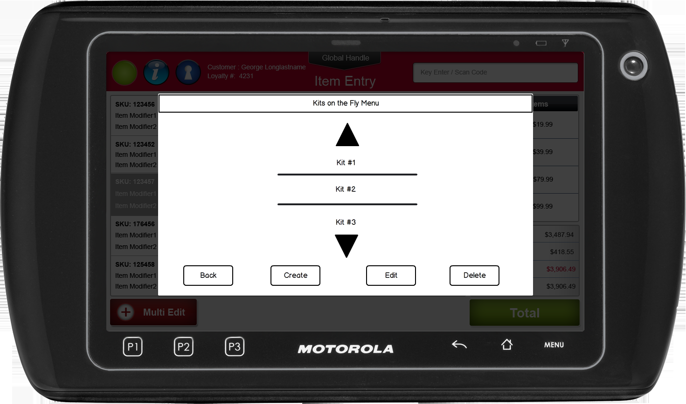

Figure 1: Kit Menu

### Instruction Text

|  |
| --- |
| **Instructions** |
| Kits On the Fly |

### Navigation/Menu Keys

|  |  |  |  |
| --- | --- | --- | --- |
| **Label** | **State** | **Next Screen** | **Notes** |
| Back | Enabled | Sale Use Case | None |
| Picker | Enabled | None | Contains the list of the Kits in the transaction. The list is in alphabetical order based upon the system generated name and kit ID. |
| Create | See Notes | Item Entry – Create Kit | Only enabled when there are eligible kit items available to create a kit, this includes checking the Kit Eligible Item Attribute and if already part of a kit. |
| Edit | See Notes | Item Entry – Edit Kit | Only enabled when a Kit is selected from the list. |
| Delete | See Notes | Confirm Kit Deletion | Only enabled when a Kit is selected from the list. |

### Data/Input Fields

|  |  |  |  |  |  |  |
| --- | --- | --- | --- | --- | --- | --- |
| **Label** | **Editable** | **Req’d?** | **Data Type** | **Min**  **Length** | **Max**  **Length** | **Notes** |
| None |  |  |  |  |  |  |

### Reason Codes

|  |  |  |
| --- | --- | --- |
| **Reason Code** | **Valid Values** | **Default Value** |
| None |  |  |

### Confirm Kit Deletion

|  |  |
| --- | --- |
| **Description** | This message is displayed when delete kit menu option is selected and Kit ID # is selected if more than one Kit in the transaction. If the operator selects:  Yes – the system removes the kit discounts on the items and returns to the Sale use case  No – the use case ends and returns to the Sale use case |
| **Message** | Are you sure you want to delete the kit? |
| **Key prompt** | * Yes * No |
| **Notes** | Configurable message |

## Item Entry – Create Kit

The Item Entry – Create Kit screen is displayed when the operator selects Create from the Kit Menu or selects Kits on the Fly from the Tran Modify menu and there are no other kits in the transaction. The screen prompts the operator to select the eligible items available to be added to a kit. The eligible items are displayed in the order they were added to the transaction.

### Mockup

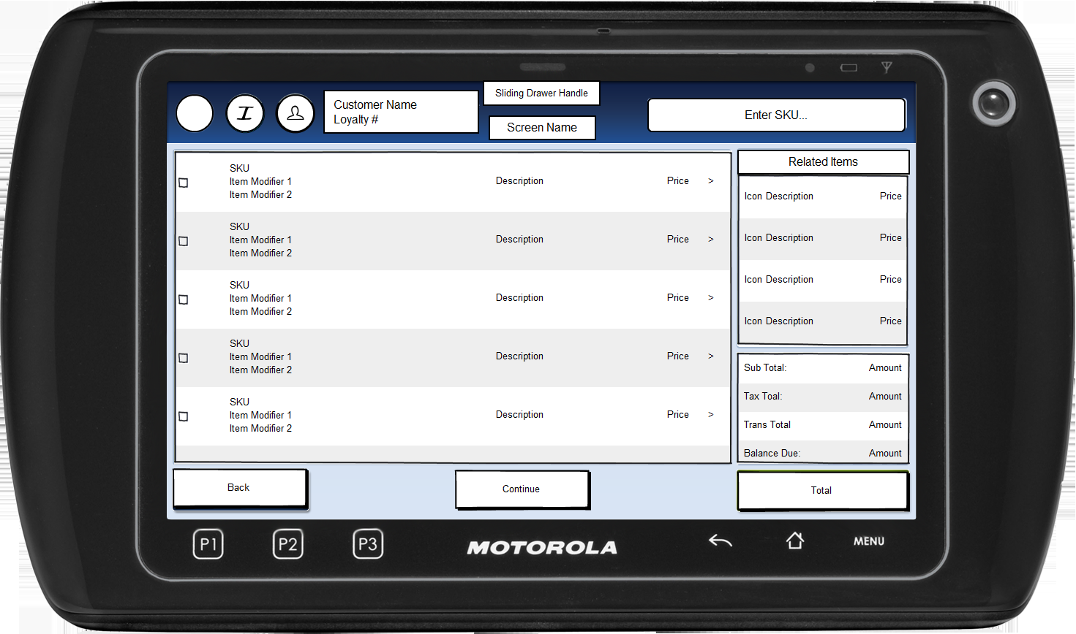

Figure 2: Item Entry – Create Kit

### Instruction Text Enhancements

|  |
| --- |
| **Instructions** |
| None |

### Navigation/Menu Key Enhancements

|  |  |  |  |
| --- | --- | --- | --- |
| **Label** | **State** | **Next Screen** | **Notes** |
| Back | Enabled | Sale use case | None |
| Continue | See Notes | * Enter Kit Price – Create Kit | Only enabled when at least one item has been checked |

### Data/Input Field Enhancements

|  |  |  |  |  |  |  |
| --- | --- | --- | --- | --- | --- | --- |
| **Label** | **Editable** | **Req’d?** | **Data Type** | **Min**  **Length** | **Max**  **Length** | **Notes** |
| Check Box by Item | Yes | See Notes | N/A | N/A | N/A | All eligible items to be added to a Kit are listed with a check box. |

### Reason Code Enhancements

|  |  |  |
| --- | --- | --- |
| **Reason Code** | **Valid Values** | **Default Value** |
| None |  |  |

## Item Entry – Edit Kit

The Item Entry – Edit Kit screen is displayed when the operator selects Edit kit menu option and selected Kit from Kit Selection Menu when there exists more than one kit exists in the transaction. The screen prompts the operator to select the eligible items available to be added to a kit, the items already in the kit are checked. The eligible items are displayed in the order they were added to the transaction.

### Mockup

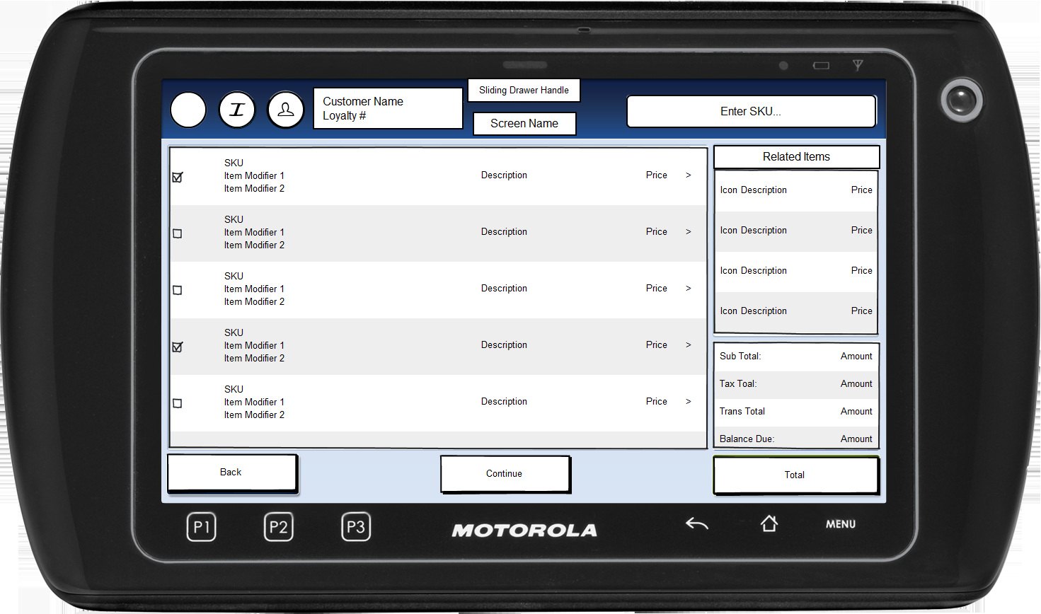

Figure 3: Item Entry – Edit Kit

### Instruction Text Enhancements

|  |
| --- |
| **Instructions** |
| None |

### Navigation/Menu Key Enhancements

|  |  |  |  |
| --- | --- | --- | --- |
| **Label** | **State** | **Next Screen** | **Notes** |
| Back | Enabled | Sale use case | None |
| Continue | See Notes | * Enter Kit Price – Create Kit | Only enabled when at least one item has been checked |

### Data/Input Field Enhancements

|  |  |  |  |  |  |  |
| --- | --- | --- | --- | --- | --- | --- |
| **Label** | **Editable** | **Req’d?** | **Data Type** | **Min**  **Length** | **Max**  **Length** | **Notes** |
| Check Box by Item | Yes | See Notes | NA | NA | NA | All eligible items to be added to a Kit are listed with a check box, those already in the kit are checked. At least one item has to be checked to Continue. |

### Reason Code Enhancements

|  |  |  |
| --- | --- | --- |
| **Reason Code** | **Valid Values** | **Default Value** |
| None |  |  |

## Enter Kit Price – Create Kit

The Enter Kit Price – Create Kit screen is displayed after the kit items have been checked in the Item Entry – Create Kit screen and the operator selected continue. The screen prompts the operator to enter the kit.

### Mockup

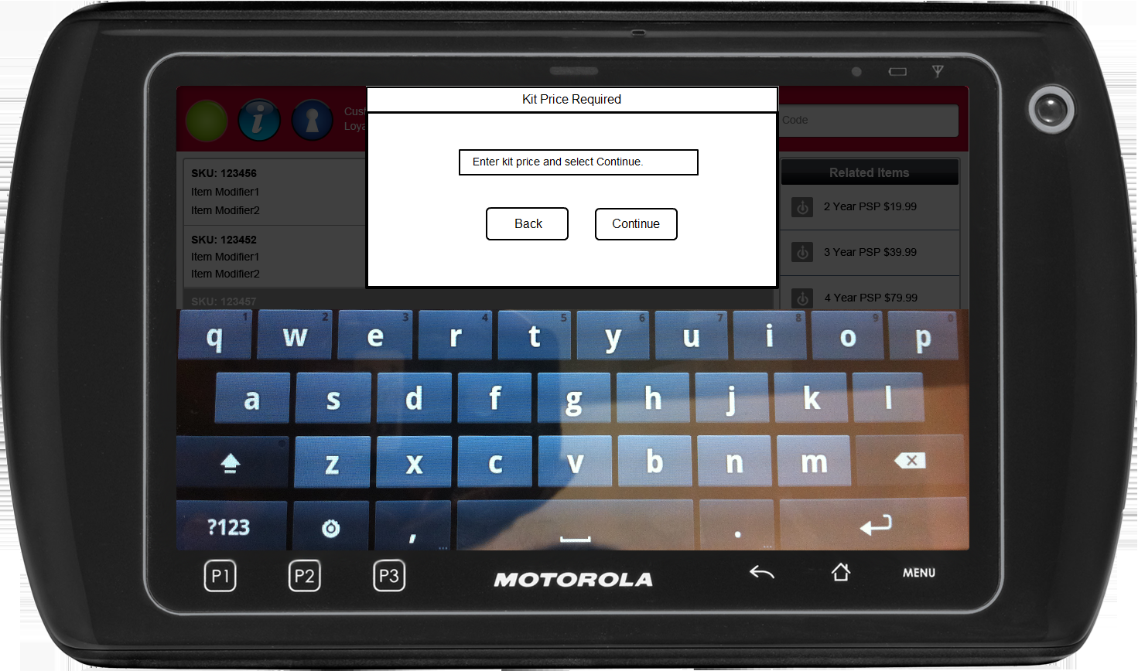

Figure 4: Enter Kit Price – Create Kit

### Instruction Text Enhancements

|  |
| --- |
| **Instructions** |
| None |

### Navigation/Menu Key Enhancements

|  |  |  |  |
| --- | --- | --- | --- |
| **Label** | **State** | **Next Screen** | **Notes** |
| Back | Enabled | Sale use case | None |
| Continue | Enabled | * Valid Price: Sale use case * Invalid Price: Invalid Kit Price | See Kits on the Fly use case for details on the validated kit price. |

### Data/Input Field Enhancements

|  |  |  |  |  |  |  |
| --- | --- | --- | --- | --- | --- | --- |
| **Label** | **Editable** | **Req’d?** | **Data Type** | **Min**  **Length** | **Max**  **Length** | **Notes** |
| Enter kit price and select Continue | Yes | Yes | Currency | 4 | 12 | None |

### Reason Code Enhancements

|  |  |  |
| --- | --- | --- |
| **Reason Code** | **Valid Values** | **Default Value** |
| None |  |  |

### Invalid Kit Price

|  |  |
| --- | --- |
| **Description** | This message is displayed when the entered kit price does not meet the requirements of a kit price. |
| **Message** | Invalid Kit Price |
| **Key prompt** | Ok |
| **Notes** | Configurable database message |

## Enter Kit Price – Edit Kit

The Enter Kit Price – Edit Kit screen is displayed after the kit items have been checked in the Item Entry – Edit Kit screen and the operator selected continue. The screen prompts the operator to enter the kit. The field is pre-populated with the current kit price.

### Mockup

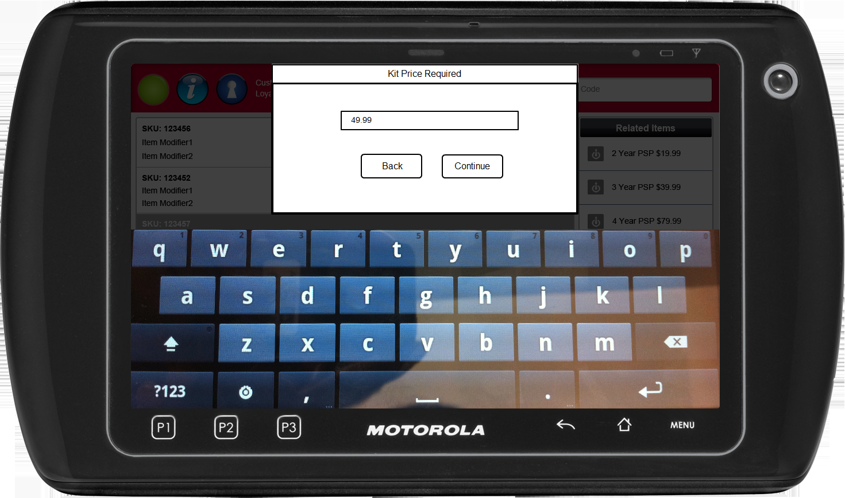

Figure 5: Enter Kit Price – Edit Kit

### Instruction Text Enhancements

|  |
| --- |
| **Instructions** |
| Kit Price Required |

### Navigation/Menu Key Enhancements

|  |  |  |  |
| --- | --- | --- | --- |
| **Label** | **State** | **Next Screen** | **Notes** |
| Back | Enabled | Sale use case | None |
| Continue | Enabled | * Valid Price: Sale use case * Invalid Price: Invalid Kit Price | See Kits on the Fly use case for details on the validated kit price. |

### Data/Input Field Enhancements

|  |  |  |  |  |  |  |
| --- | --- | --- | --- | --- | --- | --- |
| **Label** | **Editable** | **Req’d?** | **Data Type** | **Min**  **Length** | **Max**  **Length** | **Notes** |
| N/A | Yes | Yes | Currency | 4 | 9 | The field is pre-populated with the current kit price. |

### Reason Code Enhancements

|  |  |  |
| --- | --- | --- |
| **Reason Code** | **Valid Values** | **Default Value** |
| None |  |  |

### Invalid Kit Price

|  |  |
| --- | --- |
| **Description** | This message is displayed when the entered kit price does not meet the requirements of a kit price. |
| **Message** | Invalid Kit Price |
| **Key prompt** | Ok |
| **Notes** | Configurable database message |

## Item Entry – With Kit Items

The Item Entry screen allows the operator or customer to add items to a basket or select an option from the menu. Once a kit is added to the basket, the system displays the kit name below each of the SKUs in the kit. The system displays the pro-rated price applied to the kit item.

### Mockup

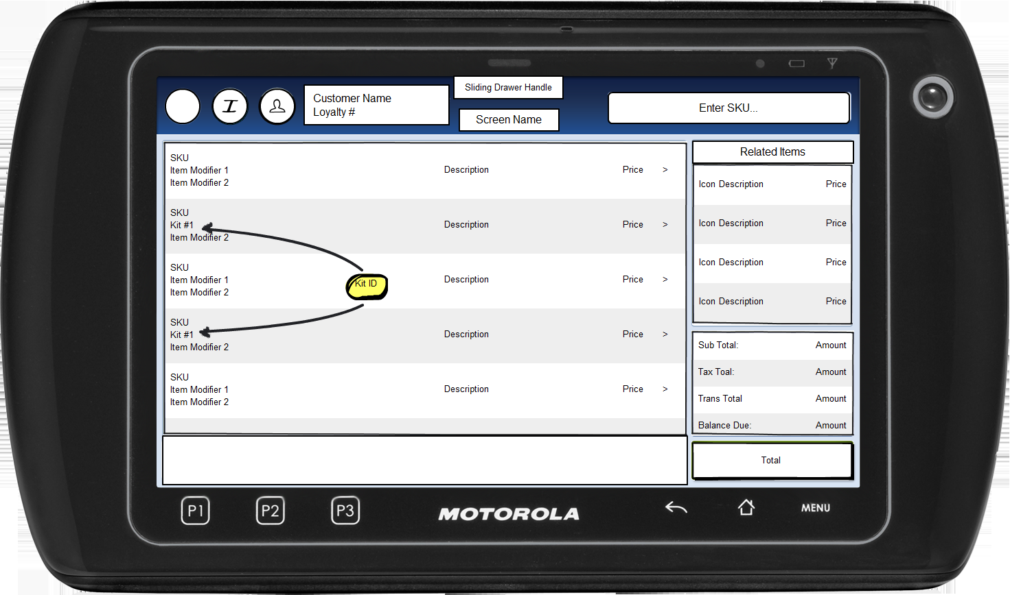

Figure 6: Item Entry – With Kit Items

### Instruction Text Enhancements

|  |
| --- |
| **Instructions** |
| None |

### Navigation/Menu Key Enhancements

|  |  |  |  |
| --- | --- | --- | --- |
| **Label** | **State** | **Next Screen** | **Notes** |
| See Sale: Item Entry Screen |  |  |  |

### Data/Input Field Enhancements

|  |  |  |  |  |  |  |
| --- | --- | --- | --- | --- | --- | --- |
| **Label** | **Editable** | **Req’d?** | **Data Type** | **Min**  **Length** | **Max**  **Length** | **Notes** |
| See Sale: Item Entry Screen |  |  |  |  |  |  |

### Reason Code Enhancements

|  |  |  |
| --- | --- | --- |
| **Reason Code** | **Valid Values** | **Default Value** |
| None |  |  |

# *Business Sign Off*

|  |  |  |
| --- | --- | --- |
| **Name** | **Organization** | **Date** |
| <Name of signer> | <Organization of signer if applicable> | <date of sign off> |

# *Revision History*

|  |  |  |  |
| --- | --- | --- | --- |
| **Reviser** | **Revision** | **Date** | **Version** |
| Amy Lackas | Initial document created. This version includes the following changes: Employee Transaction. | 07/16/2013 | 1.0 |
| Amy Byers | Added clarification that extreme discounting is evaluated and manager approval received if excess. | 9/10/2014 | 1.1 |

# *Appendix : Source Documentation*

* Requirement Specification - XPOS

## Functional Requirements

| **ID** | **Category** | **Sub-Category** | **Description** | **Section(s)** |
| --- | --- | --- | --- | --- |
| 2.20 | Functions | Kits on the Fly | Once pricing has been applied to a Kits on the Fly, current EPOS logic will be utilized to evaluate the margin threshold and determine if manager approval will be required. |  |

# *Appendix : Glossary*

|  |  |
| --- | --- |
| **Term** | **Definition** |
|  |  |